p-ISSN 2086-6380, e-ISSN 2548-7949
TITLE OF ARTICLE ←12pt, 1 space, capital, bold
(Use the Microsoft Word template style: Title)

Author^{1 *} , Author² , Author³ ←11pt, 1 space, bold
¹ affiliation/institution, address of the institution, country of origin ←10pt, 1 space
² affiliation/institution, address of the institution, country of origin ←10pt, 1 space
³ affiliation/institution, address of the institution, country of origin ←10pt, 1 space
* Correspondence Author: email address, contact number←10pt, 1 space

A R T I C L E I N F O |  |  | ABSTRACT ←12 pt, 1.5 spaces, capital Bold
Article History:
Received : Month day, 2023 Accepted : Month day, 2023 Published: Month day, 2023
DOI:
XXXX
Available online at
XXX
Jurnal Ilmu Kesehatan Masyarakat used an abstract one-paragraph format. In Abstract does not use list sources of citation. The abstract used IMRAD structure which summarizes the introduction, methods, results, and discussion. Introduction, the author explains the reasons why research needs to be done. Describe the gap analysis. Then the author mention the purpose of the study. In the method section, the authors mention the research method in outline, including design, sample selection, data analysis. In the Results section, the authors state the main results of the study. In the discussion section, the authors formulated the main conclusions of the study and implication of the study. Abstract length up to 250 words. ←10pt, 1 space
Keywords: Consist of 3 – 5 Words

Introduction ←12pt, 1.5 spaces
(Use the Microsoft Word template style: Heading 1)
In this section, the authors describe the Adequacy of the state of the art overview (minimum reference in the last 10 years) of previous journal articles. There is a gap analysis (justification why this research needs to be done and what is unique about this paper compared to previous papers. At the end of the introduction, state the purpose of the research or the hypothesis. ←11pt, 1.5 spaces
(Use the Microsoft Word template style: Normal)

Method ←12pt, 1.5 spaces
(Use the Microsoft Word template style: Heading 1)
Describe in detail the research method you are using. Identification of designs, methods, tools, and procedures in sufficient detail to allow other researchers to repeat the research. Mention statistical tests used in detail. Ethical considerations such as clinical trials, studies conducted that have received statements from relevant ethical committees must be mentioned. ←11pt, 1.5 spaces
(Use the Microsoft Word template style: Normal)

Results← 12pt, 1.5 spaces
(Use the Microsoft Word template style: Heading 1)
Present your findings in a logical order. Use the appropriate table or illustration. Likewise, the readability and accuracy of the statistical test calculations. Presentation of tables or figures is in the results section (not attached). ←11pt, 1.5 spaces
(Use the Microsoft Word template style: Normal)
Table 1. Characteristics of Respondents
(Use the Microsoft Word template style: Heading 2 for Tables title
and word on the table use Microsoft word 9 pt)

Column Header Goes Here | Column Header Goes Here | Column Header Goes Here
Row Name Here | x | x
Row Name Here | x | x
Row Name Here | x | x

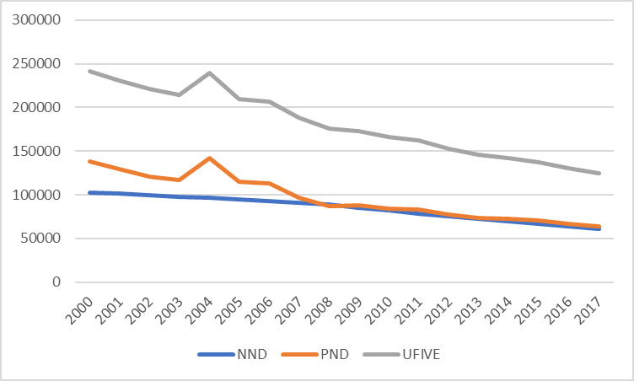

Figure 1. Trend of Neonatal Mortality Death (NND), Post Neonatal Mortality Death (PND) and Under Five Mortality Death (UFIVE) in Indonesia from 200 to 2017

Discussion ←12pt, 1.5 spaces
(Use the Microsoft Word template style: Heading 1)
The discussion is written clearly and meets the scientific aspects of merit (elements of what/ how/why and what else). Do not repeat the data in the research results section. This section describes precisely and argumentatively the results of research with relevant theories and previous findings. Emphasize new and important aspects of this research. Discuss the implications of the findings, their limitations, and link observations with other relevant research. ←11pt, 1.5 spaces
(Use the Microsoft Word template style: Normal)

Conclusion ←12pt, 1.5 space
(Use the Microsoft Word template style: Heading 1)
This section can answer the research objectives. Avoid conclusions that are not supported by the data If there are suggestions, made in one paragraph that contains conclusions and suggestions. Suggestions move to the findings. ←11pt, 1.5 spaces
(Use the Microsoft Word template style: Normal)

Acknowledgement ←12pt, 1.5 space
The authors mention acknowledgment for someone or organization who support the research←11pt, 1.5 spaces

Funding: ←12pt, 1.5 space
This study was funded by X (grant number X).
If no funding, the authors should state that they have no funding for the reasearch←11pt, 1.5 spaces

Conflict of Interest: ←12pt, 1.5 space
Author A has received research grants from Company A. Author B has received a speaker honorarium from Company X and owns stock in Company Y. Author C is a member of committee Z.
If no conflict exists, the authors should state:
The authors declare that they have no conflict of interest. ←11pt, 1.5 spaces

Reference ←12pt, 1.5 space
(Use the Microsoft Word template style: Heading 1)
Public health science journals use bibliography writing style using Vancouver (numbered in order through the entire text, not alphabetically). The serial number of occurrences is written as a superscript number without parentheses after a period in the sentence. The minimum number of references is 25 references, where 80% are from research articles / scientific journals. Reference writing is allowed at least the last ten years (2013-2023). The author is expected to be consistent in writing a bibliography. To facilitate the authors expected to use the reference manager application (endnotes, Mendeley, Zotero, etc.) ←11pt, 1.5 spaces
Example:
- Book (printed)
Simons NE, Menzies B, Matthews M. A Short Course in Soil and Rock Slope Engineering. London: Thomas Telford Publishing; 2001.
- Book (online)
Grech ED. ABC of interventional cardiology. 2nd ed. Chichester: Wiley Blackwell; 2011 Available from https://ebookcentral.proquest.com/lib/imperial/detail. action?docID=822522 [Accessed 6th July 2019].
- Article (printed)
Chhibber PK, Majumdar SK. Foreign ownership and profitability: Property rights, control, and the performance of firms in Indian industry. Journal of Law & Economics. 1999;42(1): 209–238.
- Article (online)
Errami M, Garner H. A tale of two citations. Nature. 2008;451(7177): 397–399. Available from: http://www.nature.com/nature/journal/v451/n7177/full/451397a.html [Accessed 20th January 2019].
- Conference Proceeding
Wittke M. Design, construction, supervision, and long-term behavior of tunnels in swelling rock. In: Van Cotthem A, Charlier R, Thimus J-F, Tshibangu J-P. (eds.) Eurock 2006: multiphysics coupling and long term behavior in rock mechanics: Proceedings of the International Symposium of the International Society for Rock Mechanics, EUROCK 2006, 9–12 May 2006, Liege, Belgium. London: Taylor & Francis; 2006. p.211–216.
- Report
Leatherwood S. Whales, dolphins, and porpoises of the western North Atlantic. U.S. Dept. of Commerce. Report number: 63, 2001.
- Website
European Space Agency. Rosetta: rendezvous with a comet. Available from: http://rosetta.esa.int [Accessed 15th June 2019].

